**Oracle Express Edition & SQL Learning Log**

**Student Name:** Mark Carley

**Student Number:** 20071864

**Module:** Multimedia Databases

**Course:** Creative Computing

**Lecturer:** Jacqui Woods O’Brien

**Table of Contents**

1. **Introduction**……………………………………………………………………….……....4
2. **Oracle Architecture**……………………………………………………………….4
3. **Installation**…………………………………………………………………………………..5
4. **Installing Oracle Express Edition 18c**……………………………………..5
5. **Installation SQL Developer**…………………………………………………….6
6. **Connection between SQL Developer and Oracle XE**………………7
7. **Managing Database Memory**………………………………………………………9
8. **Oracle Instance, SGA & PGA**………………………………………………….9
9. **Changing Aggregate Size**……………………………………………………….10
10. **Database Storage Structures**…………………………………………………10
11. **Monitoring Storage Space Usage**………………………………………….10
12. **Viewing Tablespace**………………………………………………………………11
13. **Viewing Redo Log Files**………………………………………………………….11
14. **Managing the Flash Recovery Area**………………………………………12
15. **Creating Tables**…………………………………………………………………………..13
16. **Inserting Records into Tables**……………………………………………….14
17. **Creating Foreign Keys**…………………………………………………………..14
18. **Triggers**…………………………………………………………………………………15
19. **Views**……………………………………………………………………………………15
20. **Sequences**…………………………………………………………………………….16
21. **Managing User & Security**……………………………………………………..…..17
22. **Schema**…………………………………………………………………………………17
23. **System/Object Privileges**…………………………………………………….17
24. **Roles**…………………………………………………………………………………….17
25. **Administrative Accounts & Privileges**………………………………….17
26. **Management of User Accounts**……………………………………………18
27. **Creating Users**……………………………………………………………………..18
28. **Altering Database Users**………………………………………………………19
29. **Dropping Users**…………………………………………………………………….20
30. **Locking & Unlocking User Accounts**…………………………………….20
31. **Expiring a User Password**…………………………………………………….20
32. **Exporting & Importing Metadata and Data**………………………………..21
33. **Importing Data from a Microsoft Excel File**………………………….21
34. **Exporting Data (Wizard)**……………………………………………………….22
35. **Importing Data (Script)**………………………………………………………..23
36. **Backing Up & Recovering**……………………………………………………………24
37. **ARCHIVELOG Mode**………………………………………………………………24
38. **Backing Up the DB**………………………………………………………………..25
39. **Restoring & Recovering the DB**…………………………………………….25
40. **Flashback Query**……………………………………………………………………25
41. **Recovering Dropped Tables**………………………………………………….26
42. **Recycling Bin**…………………………………………………………………………26
43. **Queries**……………………………………………………………………………………….28
44. **Reflections on the process**………………………………………………………….28
45. **Problems Encountered**……………………………………………………………….29
46. **Resolutions to Problems**…………………………………………………………….29
47. **Conclusion**………………………………………………………………………………….30
48. **References**………………………………………………………………………………….31

1. **Introduction**

The following report will outline the process of creating a database using SQL developer and setting up and adding features to the database. The document will detail the installation of Oracle XE and SQL developer, managing database memory, creating tables, managing users and security, exporting/importing metadata and data, backing up the database, triggers, timestamping, timestamping of tables and problems encountered while creating the database.

The type of database I am trying to create here is that of an airline booking system, the system will record customer information (name, address, num etc.) and process their ticket information for incoming and outgoing flights. Flights will consist of 4 tables called flight details, flight takeoffs, airports and airplanes. The customer will also have their own flight ID and luggage details connecting as a separate table.

**Oracle Architecture**

The Oracle architecture has many different components that work together to keep a functioning database together. The architecture allows the user to read/write data to tables in more efficient ways.

Oracle architecture is composed of three main components, the oracle instance, database storage and server processes.

* **Oracle Instance** – A non-persistent program that is loaded when the database is started. The program is loaded into the ram of the computer until it is shutdown.
* **Oracle Database Storage** – A collection of disks that make up the physical Oracle database. Files are maintained within disks and are used to maintain persistence of data between storage and memory.
* **Server Processes** – Are created by the Oracle database to handle the requests of user processes. A server process can be either a server process (services one user process) or a shared user process (handle multiple user requests).

1. **Installation**

The two pieces of software to install are both Oracle Express Edition 18c and SQL developer, the oracle database is a backend program while SQL is the frontend tool used to interact with it. The process for installing Oracle Express Edition 18c was difficult at first due to the operating system being used but once resolved was simple enough to install. One of the steps that Oracle Express asks is to setup a password for admin access which is important for SQL developer later. SQL developer doesn’t have an installation, it’s a ready to launch program once downloaded and unzipped.

**Installing Oracle Express Edition 18c**

Once the application was downloaded, I clicked on the executable for the installation wizard. The process is simple enough but taking into consideration the password inserted for use later and deciding where to install the program on the machine downloaded from.

Below is the message to select what password to setup when logging into SQL developer once finished.

Lastly the program will install and ask to bypass windows firewall when in use, clicking install will install the files into the necessary folders picked earlier. Once installed the program will bring up a prompt to finish.

**Installing SQL Developer**

Once SQL Developer was downloaded from the following source (<https://www.oracle.com/tools/downloads/sqldev-v192-downloads.html>), It was just a matter of unzipping the files and placing them into the correct location on the desired computer.

When the file is extracted, I clicked on the executable for SQL Developer and brought up the following user interface when opened.

**Connection between SQL Developer and Oracle Express Edition 18c**

The first step to take when connecting SQL Developer and Oracle XE is to setup a new database connection. The first connection we make is done via SYSTEM account which sets up a new user and let us perform different operations later.

To create a new connection, press the green plus icon on the top left corner in SQL developer to create a connection.

Once the green plus is pressed, it brings up the connection form. The connection name is called “XE”. The username is “sys” and password which was the setup on Oracle XE during installation. The system role is “SYSDBA”. Everything else on the form is left alone.

When all the required information is filled in, I test the connection using the “test” button and shows successful connection. If it’s successful we press connect and it should show a small prompt with username (already filled as sys) and password to insert and that’s everything.

1. **Managing Database Memory**

**Oracle Instance**

When using Oracle, many back-ground processes in a database need space on a computer to run efficiently. An Oracle instance “contains the set of Oracle database background processes that operate on the stored data and the shared allocated memory that those processes use to do their work” (Managing the Oracle Instance, 2020).

An instance must always be started to read/write information to a database. It’s the instance that creates a database from instructions of the Oracle Database Configuration Assistant (DBCA) utility or the SQL statement called “CREATE DATABASE”.

While the database itself will include all application data and metadata stored in physical files on a server, an instance is a combination of the software and memory used to access that data. For example, if you log into a Oracle database, that login session is an instance. If you shut down or restart your computer, that instance is gone but the database and data remain. An Oracle instance can only access one database at a time, while a Oracle database can access multiple instances.

A SQL Server means a specific installation of a SQL server. It isn’t a data-base, it is software used to create a database. Having multiple instances open and maintained could be useful when managing server resources because each instance can be configured for CPU usage and memory, which is something you can’t do for individual databases within a SQL server instance.

**SGA, PGA and Aggregation**

An Oracle instance can use two types of memory both SGA and PGA.

* The System Global Area (SGA) is a shared group of memory structures, known as SGA components. It contains data and controls information for one Oracle database instance. The components that SGA is composed of is the buffer cache, shared pool, redo buff logger and large pool.
* The Program Global Area (PGA) is a private region of memory that contains data and control information for a server/client process. Only server processes can be PGA. New processes are created when a user connects to the database.

One of the main differences between SGA and PGA is that PGA cannot be shared between multiple processes, it’s only used for requirements of a particular process while SGA is used for whole instance and is shared. The sizes of both SGA and PGA are reliant on the amount of memory the computer has.

**Changing Aggregate size**

To change the SGA and PGA aggregate sizes, the first step to take is to navigate in SQL Developer and click view, then DBA to display a new navigation window. When the window opens, add the XE database connection. From here I clicked on the XE account, expand Database Configuration, and click Initialization Parameters.

In the connections navigator I selected the XE connection and opened a new SQL worksheet and entered the following lines:

* ALTER SYSTEM SET pga_aggregate_target = 140 M;
* ALTER SYSTEM SET sga_target = 472 M;

From here I right clicked the SQL worksheet and pressed Run Script to execute the two statements. The last step to take was to restart the database for the changes to take effect.

**Database Storage Structures**

There are three main storage structures, logical, physical and recovery-related structures.

* Logical structures are the tablespaces that are created in the database.
* Physical structures are just the physical files stored on disk.
* Recovery-related structures are the redo logs, archive logs, library logs and control logs used during recovery of a database.

**Monitoring Storage Structures**

Is the process of monitoring the amount of free storage space and storage space used for tablespaces which contain user data. The current maximum file amount of data that Oracle XE can hold is 4 gigabytes.

A free space report can be done to find out storage information in SQL Developer. To do this the user must click on view tab then reports, under reports tab click data dictionary reports, database administration, storage and then free space.

**Viewing Tablespaces**

Viewing tablespaces can be done very similar to monitoring storage, again click into reports, data dictionary then storage. In storage click onto Tablespaces and it will ask to confirm connection and to enter any bind values which is left null.

Clicking into an individual tablespace shows the indexes and any tables in that tablespace. Tablespace storage can grow beyond its normal size depending on datafile settings but can only grow at 10mb at a time.

**Viewing Redo Log Files**

Redo log files are operating system files which are used to maintain logs of a transaction performed on the database. Redo logs are made of two or more pre-allocated files that store changes made to a database and every instance of an Oracle database has online redo logs to help protect the database in case of failure.

In case there’s ever a failure to a database including the redo log itself, Oracle Database allows a **multiplexed redo log**, which means that two or more copies of a redo log can be maintained in two separate locations. Multiplexing a redo log also requires members to each redo log group made.

An **archived redo log file** “is a copy of one of the filled members of a redo log group. It includes the redo entries and the unique log sequence number of the identical member of the redo log group” (Managing Archived Redo Logs, 2020).

A **control file** is a small binary file that records the physical structure of a database. A control file includes:

* Database name
* Names/locations of datafiles and redo log files
* Timestamp of database creation
* Log sequence number
* Checkpoint number

The control file is created at the same time of the database and must always be available when the database is open. If the control file isn’t present it means the database cannot be mounted and makes recovery harder. It’s therefor important to make copies of the control file if an operating hasn’t already done so.

To view a redo log, open the DBA navigator under view then expand the connection that was made earlier in the navigator. In the connection look for storage and select redo log groups. The redo log groups contain all members.

**Managing the Flash Recovery Area**

The Flash Recovery Area is where all recovery-based files and backups are stored. The area is responsible for monitoring its available space and change the area’s location and size. The Flash Recovery Area has a fixed size of 10gb which can be changed later if needed.

1. **Creating Tables**

Tables in Oracle Express are used for storing records of all sorts. To create a new table in SQL Developer, right click the tables section under the database connections and select new table which we select from the list.

Once new table is selected, a new dialog box will appear with the title name of the table which can be changed. A green plus will appear which will generate new columns for the table, beside each column is name, datatype, size, null select and whether a column can be selected as a primary key. Comments can be added in each column and to add a primary key, press the left most box at the start of the column.

The following table names I inserted into my database where airline customer, airline airport, airline tickets, airline airplane.

**Inserting Records into Tables**

A minimum requirement of 5 rows per table is required for the database. To insert a row into a table, go into connection, tables, select the desired table which will bring up a new tab with information. In the tables tab I click the data sub heading then insert row, each column with have separate constraints with each input needed.

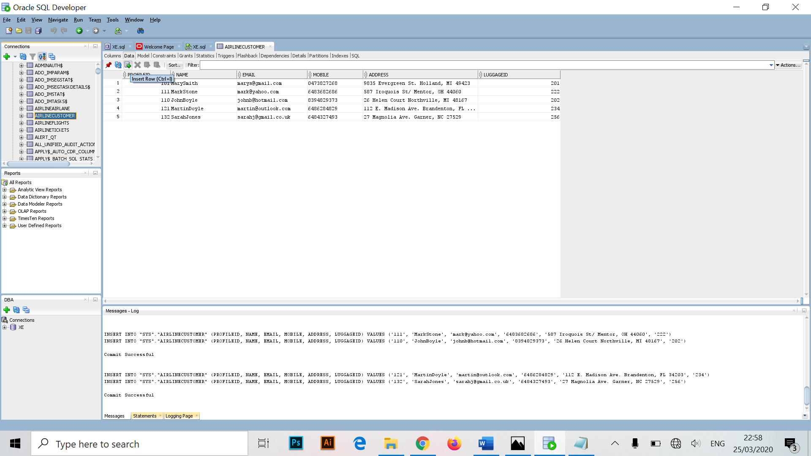

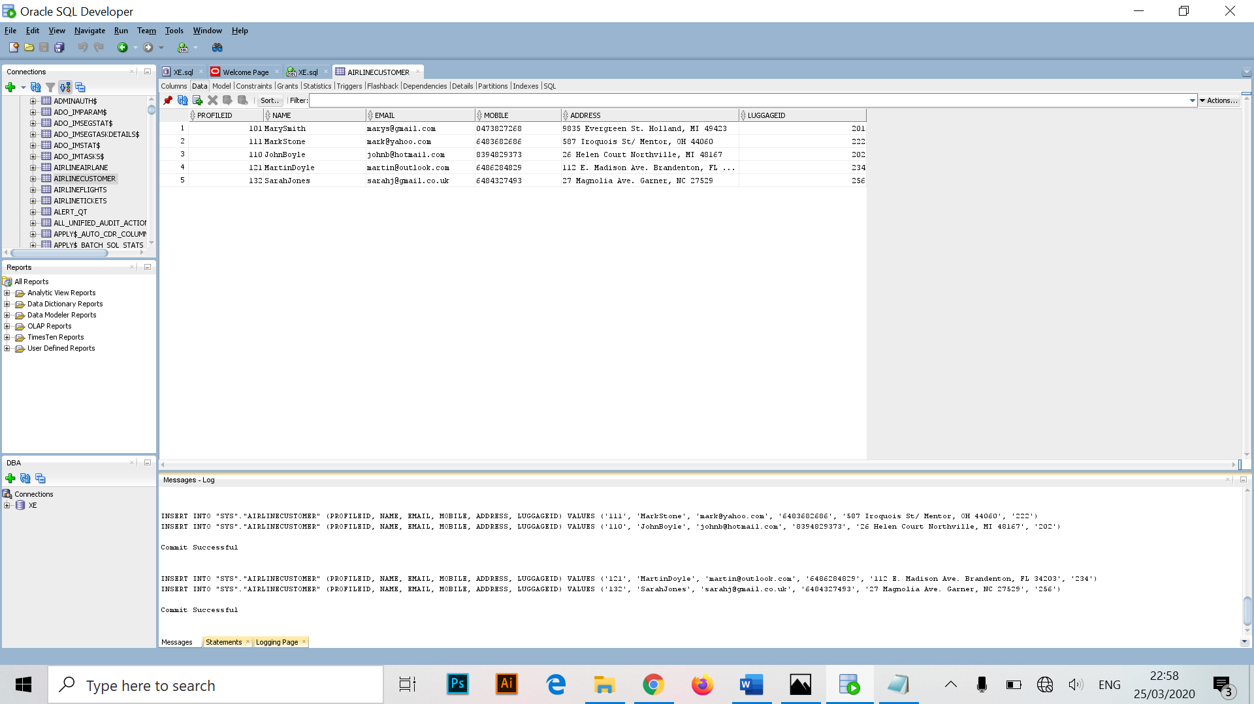Below is an example of my own row inserts for the airline customer table with its desired values in each column. When a row is filled, click commit changes which will print out the results.

**Creating Foreign Keys**

To add foreign keys to tables, the first thing to do is navigate to tables in the connections navigation menu and click on a table. Find the specific table you want and right click, constraints and add foreign key. A new window will appear with different field names, the first being Schema name and second being the table name.

The constraint name is just the name of the foreign key, the column name is what column the foreign key is place under. The referencing Table Name and Column is what table and column the foreign key is referenced to.

**Triggers**

“A trigger is a named PL/SQL block stored in the Oracle Database and executed automatically when a triggering event takes place” (Oracle Trigger, 2020). It uses a data manipulation language (DML) that executes statements against a table (insert, update, delete). For the report we are required to make two triggers. To create a trigger, right click on the triggers folder in connections nav drawer and click “New Trigger”.

When you select “New Trigger” a new field is created and code generated, the actual executable code is placed between “BEGIN” and “END”. Above are the two triggers setup in SQL Developer.

**Views**

A view is a virtual table that doesn’t physically exist. It’s store under connections in the Oracle data dictionary and doesn’t store any data. It can be called while executed and is created by a query joining one or two tables. Views are for b who can only access certain content of a table rather than the whole thing.

To create a view, right click on the view folder and select the option “New View”. A new menu schema will open asking for the name of the view and to input the SQL query.

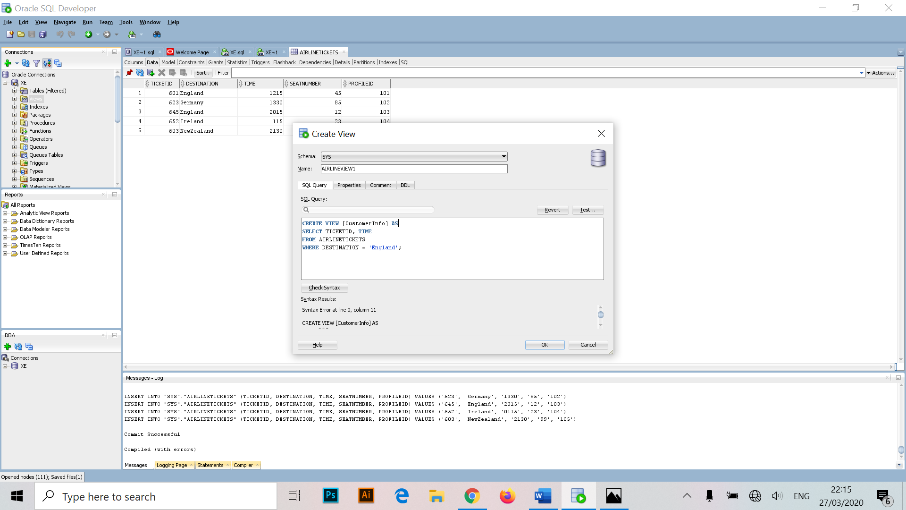

**Sequences**

A sequence “is a set of integers 1,2,3, … that are generated and supported by some database systems to produce unique values on demand” (SQL | SEQUENCES-GeekforGeeks, 2020). Using a CREATE SEQUENCE statement can create a sequence which is a database object from which multiple users may generate multiple integers. A user can use sequences to automatically generate primary key values.

To create a sequence, navigate through the connections tab and scroll down to sequences. Right click sequences and select Create Sequence.

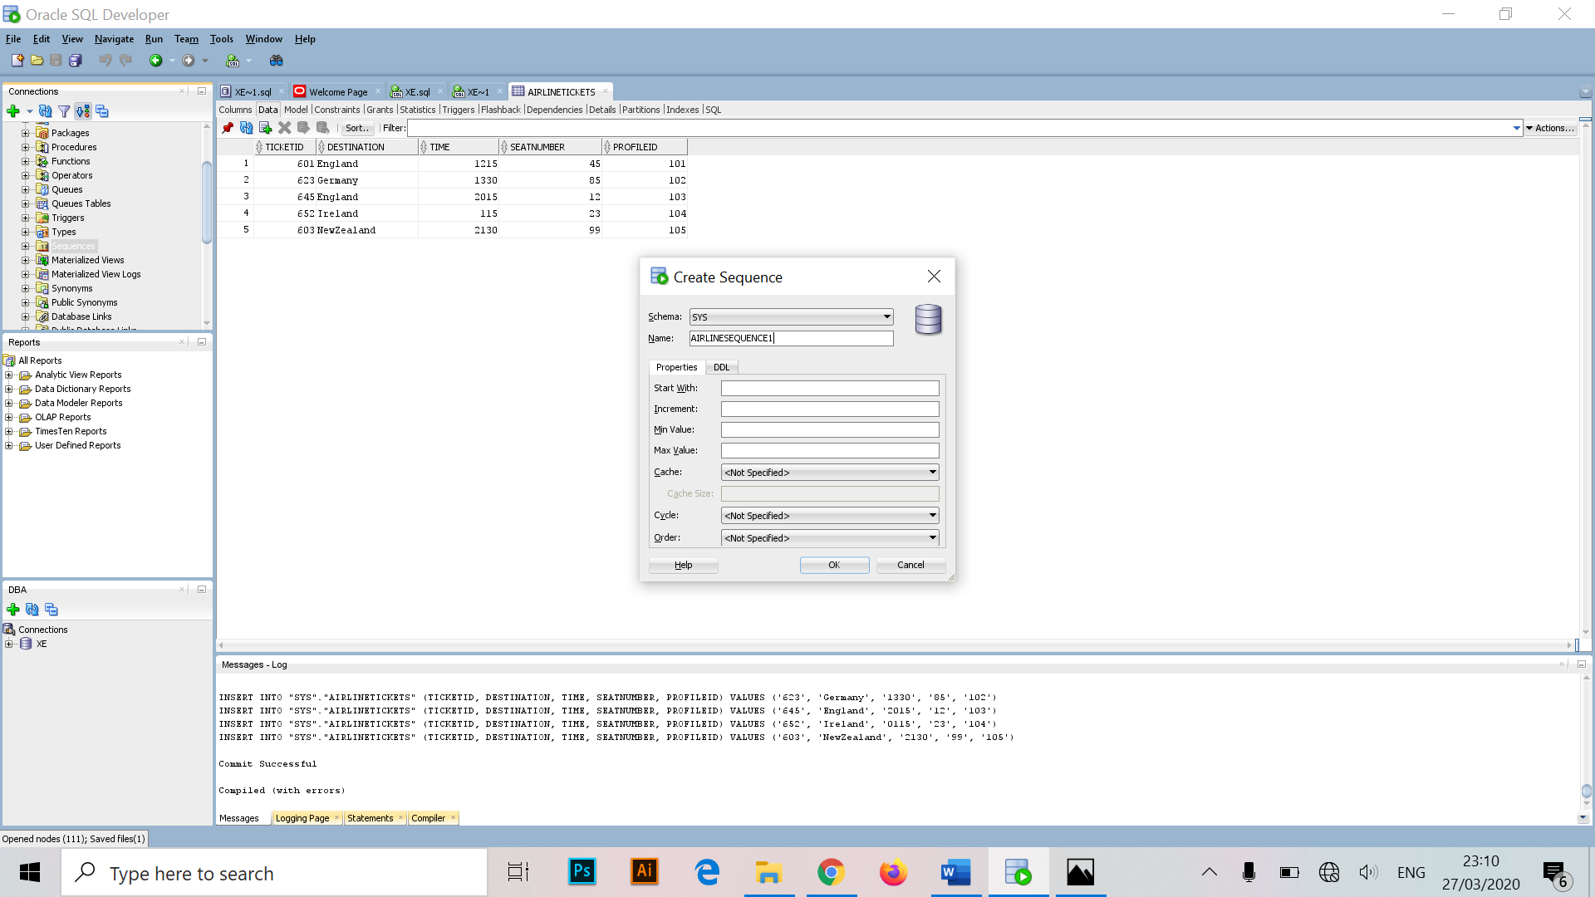

1. **Managing Users & Security**

**Schema**

When you create a user, were also creating a schema for that user. A **Schema** is a logical container for database objects such as tables, views and triggers that a user creates. The schema name is the same as the username and can be used to refer to objects owned by the user.

Example (*AIRLINE.STAFF* refers to a table’s called *STAFF* in the *AIRLINE* schema)

**System/Object Privileges**

When you create a user for a database, you grant privileges to that user to connect to a database, run queries and create schema objects. There are two main types of privileges:

* A system privilege is the right to perform an action or to perform an action on any schema object in a database (create/delete tables).
* An object privilege is the right to perform an action on a specific schema object. Different object privileges are available for different types of schema objects for example the privilege to delete rows from the AIRLINE_TICKETS table is an object privilege.

**Roles**

The use of roles in Oracle Express Edition helps the user make changes and control privileges. An example of this would be the DBA role to allow users to perform administrative tasks in SQL Developer. In SQL Developer the SYSTEM user is granted the DBA and Admins have to be cautious when in granting the role to other users. There are different roles that can be applied to a user that can cover a wide range of different tasks.

**Administrative Accounts & Privileges**

Having a administrative account setup with privileges allows that user to perform administrative functions on the database such as managing users, managing database memory and starting up/ shutting down the database.

There are two main administrative user accounts that are created when you install Oracle Database Express Edition. They are both setup with the password setup when setting up the database upon installation. These accounts are called internal user accounts and their schemas are known are internal schemas.

The two type of accounts are as follows:

* **SYSTEM**

This is the account you log in with to perform any administrative functions to the databases just not starting up or shutting down the database.

* **SYS**

The SYS schema is responsible for storing all base tables and views for the database data dictionary. The base tables are important to the Oracle Database XE as they are used to maintain integrity of the data dictionary, tables in the SYS schema are manipulated only by the database.

**Management of User Accounts**

The following actions can be carried out by a user with administrative privileges below.

**Creating Users**

After installing and setting up a connection to the database server using the SYSTEM account, the first thing to do is make a “admin main user”. This user acts as the administrator and the database required for this report was to be built in its schema. Different changes and features will be applied to the database when using this user.

To create a user, scroll down in connections until you see other users. Right click other users and select create user to start the next process.

A new dialog box will appear on the first tab which will ask for a username, the username I will be using is “airline admin”. Below username and password, I set the default tablespace to USERS and temporary tablespace to TEMP.

The next step is clicking onto granted roles, since we want this user to have administration privileges we click [Admin All] and [Default All] to give access.

The next tab called system privileges, press the [Grant All] and [Admin All] buttons but make sure to uncheck both SYSDBA and SYSOPR under system privileges so that the user has full privileges. If these two privileges were still ticket the system would not create this user.

**Altering Database Users**

In connections go into other users and right click, select [Edit User] from the list. The same dialog will appear when creating a new user earlier. This allows us to change attributes in granted roles and system privileges.

**Dropping Users**

Dropping a user removes that user from the database but before you drop a user, what must be done first is to drop all the user’s schema objects. Alternatively you can use the cascade feature of the drop operation, which simultaneously drops a user and that user’s schema objects. Dropping a user is done by right clicking a user and pressing drop user at the bottom of the list.

**Locking and Unlocking User Accounts**

A user account can be locked to prevent the user to access the database. This is done by right clicking an existing user and select [Edit User]. When the dialog box appears a tick box will appear below called [Account is Locked] which can be checked or unchecked.

**Expiring a User Password**

When a user password expires, there prompted to change that password the next time they login. This is done only in the case where a user has forgotten their password or when a user becomes compromised for policy reasons. The steps involved are as follows:

* Right click a user
* Select edit user
* Tick/Untick box that says [Password expired (user must change next login)].

1. **Exporting & Importing Metadata and Data**

Data such as tables can be exported in the form of a .sql file, which can be then used to import that using the script file and the SQL worksheet.

**Importing Data from a Microsoft Excel file**

This section assumes you want to import data from another source, in this case were using a Microsoft Excel file as the import. To do this the first step is having a connection open in SQL Developer and then opening that connection. From here we make a new SQL worksheet and type the following:

**create table new_regions (**

**region_id number primary key,**

**region_name varchar2(25));**

Once typed out click the run script icon and it should return an output saying NEW_REGIONS table has been created.

In the connections navigator, expanding the tables section should now show the NEW_REGIONS table. If it doesn’t show then disconnect from connections and connect again. Using Microsoft Excel, open a .xls file exported out from SQL Developer which I’ll mention later and add additional rows of information. Then save and close the .xls file.

In SQL Developer, in the connections navigator for the database XE, right click the NEW_REGIONS table from before and select Import Data. It will display a dialog box to navigate the folder location where the export.xls is located, then select open.

The figure above is the import wizard for selecting our existing .xls file, once selected, press next on the next few prompts until finished.

**Exporting Data (Wizard)**

Data can be exported in order to import to another Oracle Database or a non-Oracle database provided it’s in the right format. SQL Developer provides a wizard for both importing and exporting data.

In SQL Developer, click Tools, then click database Export. This will then display the first page of the Export Wizard.

You can change the source destination of the file to whatever you want, for ease of purpose I chose documents. For the connection I chose XE as my default. Make sure to uncheck the box that says [Export DDL], if it’s checked it will display the create statements, but only insert statements.

For the format option it’s important the user selects .xls format. Click next button and will be brought to the export page, untick everything except [Tables] option. Clicking next again will bring the user to the specify objects page, click Lookup and find the REGIONS table created earlier.

By default, all data from the specified table or tables is exported. To limit the amount of data exported, specify one or more “WHERE clauses” at the bottom of the page. Clicking next will then bring the user to a summary page for reviewing information, click finish and the data will export to the chosen destination.

**Importing Data (Script)**

The first step to take is to establish the connection to the database and open up the connection. In a SQL Worksheet for the EX connection setup and typed in the following:

“@c:\Users\marku\OneDrive\Documents\export.sql”

From here I clicked run script and the output panel displayed that the REGIONS table has been created and four rows inserted. Going back to the connections navigator and expanding tables node a new REGIONS table is shown.

1. **Backing Up & Recovering**

Backing up and restoring your database is very important as it protects the physical files that make up a database such as the datafiles, control file, server parameter file and redo log files (if in ARCHIVELOG mode).

**ARCHIVELOG mode**

Turning on/off ARCHIVEMODE is relatively straight forward, the first thing to do is open SQL Command Line and sign in as SYSDBA and enter the following command:

“*SELECT log_mode FROM v$database;*”

The LOG_MODE will either display ARCHIVELOG (on) or NOARCHIVELOG (off). To enable ARCHIVELOG mode, I start by entering the following command in SQL Command Line:

“*SHUTDOWN IMMEDIATE*”

If the command is successful it displays the following output:

“*Database closed.*

*Database dismounted.*

*ORACLE instance shut down*.”

At the SQL Command Line prompt, I enter the following statements:

“*ORACLE instance started*” , “*ALTER DATABASE OPEN;”*

**Backing up the DB**

Scheduling **automatic backups** can be done in the Oracle Database by running the Backup.bat file in the location for Oracle XE (C:\oraclexe\app\oracle\product\11.2.0\server\Backup.bat) which will setup automatic backups. The scheduler inside of SQL Developer can be to produce automatic backups and allows some users to make scripts run automatically.

**Restoring and Recovering the DB**

Backing up the database is done by clicking start on windows to view programs, scroll to Oracle XE and running the “restore database” program from the computer and will ask to request confirmation. Once finished the program will display the location of the log file and restore the computer, in this case it also asked to restart the machine also.

If and when an error occurs, the screen will display an error but will display its location to be fixed later.

**Flashback Query**

The Flashback query feature allows a user to view data at a point in time in the past. You can then recover and reconstruct data that was previously deleted or edited at an earlier state. A Flashback query is a little different to a normal query as it doesn’t change any data and usually have a clause attached to it such as time or a system change number. It is up to the user to analyze past data via statements and reconstruct and restore that data. Below is an example of a Flashback query sourced from the Oracle documentation manual.

Flashback query looking for data:

*SELECT * FROM employees AS OF TIMESTAMP TO_TIMESTAMP ( ‘2005-04-04 09:30:00’ , ‘YYYY-MM-DD HH:MI:SS’ ) WHERE last_name = ‘Chung’ ;*

If the query is successful the data should find a statement using this information which can be used to reinsert data back into the table.

*INSERT INTO employees (SELECT * FROM employees AS OF TIMESTAMP TO_TIMESTAMP (‘2005-04-04 09:30:00’,’YYYY-MM-DD HH:MI:SS’) WHERE last_name = ‘Chung’);*

**Recovering Dropped Tables**

When you drop a table, it doesn’t mean it’s completely removed from the database. Instead what happens is the database renames the tables and places it a dependent object in the recycling bin. If a table is dropped by accident, it can be recovered at a later time.

**Recycling Bin**

The recycling bin is a table within the data dictionary that stores all dropped objects in a database. Different kinds of dropped objects include indexes, constraints and nested tables which are not removed until they are automatically purged from the database when there’s a short supply of memory space. You can also restore objects from the recycling bin as well which restores a table and all it’s dependent objects where this is called “un-dropping”.

**Viewing the Contents**

To view the contents of the recycling bin in SQL Developer I did the following:

* Open-up the database connections.
* Expand the connections and select the Recycle Bin node.
* Click a table (if any) to see the properties of those tables.

**Restoring from the Recycling Bin**

To restore a dropped object from the recycling bin I did the following procedure:

* Right click an object and select the Flashback to Before Drop.
* A new pop will appear.
* Then specify the desired name and select apply.

Below is the pop box that appears after confirming Flashback to Before Drop.

**Purging the Recycling Bin**

As mentioned earlier when you drop an object to the recycling bin, the space is not freed until an automatic purge or when purging the objects directly. Below is the process of events for purging an object in SQL Developer:

* In the connections navigator, expand the recycling bin.
* Right-click the desired object and select purge.
* A confirmation box will appear, click apply.

1. **Queries**

* SELECT profileid, firstname, lastname, email, phonenumber, address1, address2, address3 FROM airlinecustomer WHERE profileid LIKE ‘%1004%’;
* SELECT firstname, lastname, address1, address2, address3 FROM airlinecustomer ORDER BY lastname asc;
* SELECT COUNT (flighted) FROM airlineflights WHERE numberofseats >130;
* SELECT ticketed AS FIDs FROM airlinetickets UNION SELECT profileid FROM airlinecustomer;
* SELECT airlineexample.ordersid, airlinecustomer.profileid FROM airlineexample INNER JOIN airlinecustomer ON airlineexample.profileid = airlinecustomer.profileid;

1. **Reflections on the process**

Over the course of doing this assignment I found it to be extremely long, but did learn a lot in regards to SQL Developer and Oracle XE. It allowed me to get a better understanding of the system and in doing so gave a better reflection on how to use the SQL command line tool as well. I definitely found the Oracle Documentation to be extremely helpful when going through this assignment overall.

**10.Problems Encountered**

While doing the assignment I ran into multiple problems, the first being the installation of Oracle Express Edition 18c on my own machine, when trying to install the progress would roll back and give a prompt saying installation finished with errors. Another problem that incurred was the connection to the Oracle database where it would fail completely when trying to connect with SQL Developer.

Another problem was the creation of users on the database where it would return an invalid username/password even though it was valid and had no duplicates in SQL Developer. An issue also occurred when trying to login as different users in SQL Developer but would allow signing through the SQL command prompt version. Other than these issues provided I did not encounter any other problems during the assignment.

There was a ongoing issue when using the current version of Oracle 18c where it wouldn’t allow the creation of other queries or creating views, sequences of queries.

**11. Resolutions to Problems**

To address the installation issue, the first step I took was to re-download a copy of Oracle XE 18c and delete the current files off the machine. From here I went through the C drive directory and made sure to delete all timestamp files associated with Oracle XE. Once all that was done I installed the software again using the install with admin privileges icon and it worked.

The connection issue was fixed finding an online solution where I had to find the “tnsnames.ora” and “listener.ora” files located in the Oracle XE installation and change the port value from 1521 (default) to localhost instead for both files. After those changes were made it connected as normal.

The other problem where other users couldn’t be created via SQL Developer was addressed by inserting the following code into a worksheet before creating a user.

“alter session set "_ORACLE_SCRIPT"=true;”

To address the Oracle 18c issue I uninstalled the latest version and instead installed an older version of Oracle XE called 11g, since installed it’s fully addressed user creation, creating views, sequences and queries for the assignment.

**12. Conclusion**

Overall the report listed out all the key features in regards to the Oracle architecture and went into detail with storage, caches, background processes and structures. It then walked through the full installation and connection between Oracle XE and SQL Developer, then walks through the different functions of the system along with all the key uses of each. Once everything was explained the report then lists out any problems, resolutions to those problems and references to any external sources used.

**13.References**

**Managing Database Memory:**

Docs.oracle.com. 2020. Managing The Oracle Instance. [online] Available at: <https://docs.oracle.com/cd/B28359_01/server.111/b28301/instance.htm#ADMQS005> [Accessed 22 March 2020].

Docs.oracle.com. 2020. Managing Archived Redo Logs. [online] Available at: <https://docs.oracle.com/cd/B19306_01/server.102/b14231/archredo.htm> [Accessed 25 March 2020].

**Creating Tables:**

Oracle Tutorial. 2020. Oracle Trigger. [online] Available at: <https://www.oracletutorial.com/plsql-tutorial/oracle-trigger/> [Accessed 27 March 2020].

GeekforGeeks, 2020. SQL | SEQUENCES – Geeksforgeeks. [online] Available at:

<https://www.geekforgeek.org/sql-sequences/> [Accessed 27 March 2020].